GROOMING YOUR PWD
PWDCNC Member Event

Part 1: Intro to Grooming Tools - Zoom Video Seminar
Tuesday, July 26, 7:00-8:00 pm
Part 2: Hands-on Workshop – You Groom Your PWD!
Saturday, August 25, 9AM – 3 PM
Tailored Dog Training Facility, 4475 Treat Blvd Suite K, Concord, CA 94521

Does your PWD’s cut look like shrub… or worse yet, like a Doodle?
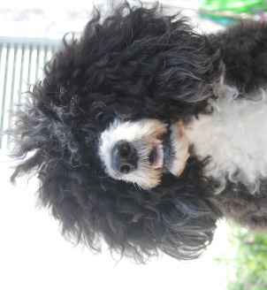
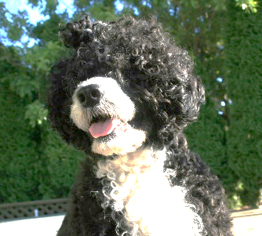
Is grooming a dangerous contact sport at your house?
Feel you’re losing the battle of the mats?
Wonder how to stop the “itchies”?
Live in constant fear that your groomer may fire you?
Is nail cutting a battle of wills?
If you’re tired of hearing “Is that a black Bichon???” or other such nonsense, GET THE SCOOP on how to safely and beautifully groom your PWD to look like a PWD.

DETAILS
Part 1: Intro to Grooming Tools
Tuesday, July 26, 7:00-8:00 PM, Zoom Video Seminar – Video Call-in info will be forwarded to Registrants
Kick back and watch a review of the various grooming supplies and equipment you need to get started grooming your own PWD. Get the skinny on shampoos, conditioners, clippers, scissors, dryers, grooming tables and more. You’ll be provided with a list of essential and “nice to have” tools and where to purchase. Session led by Ally Lantis. Even though this event is free of charge, please sign up below.

Part 2: Hands-on Workshop with your PWD (Audit slots available)
Saturday, August 25, 9AM – 3 PM, Tailored Dog Training Facility, 4475 Treat Blvd Suite K, Concord, CA 94521
For our hands-on workshop, Ally Lantis and volunteers will go over the following exercises with you and your PWD:
- Grooming manners, such as being on the table, allowing combing, not battling the blow-dryer, allowing trimming and shaving on face, acceptance of nail trims
- How to properly demat and when to start over by shaving the coat down entirely (it’s just hair; it’ll grow back!)
- Demos on trained dogs (Ally will provide demo dogs) will show how to use grooming tools properly and which styles best suit different dogs’ body shapes and coat types.

IMPORTANT: Every PWD (and its owner) have unique skills: Some dogs and owners might be ready to do actual scissor and clipper work during the workshop with their own tools, and other teams may still be learning grooming manners and taking it slow. While there will be volunteers to assist you, please do not expect them to groom your dog for you. You will be doing the grooming yourself! You will need to bring your own grooming supplies (see below for more information*). You can also attend the workshop without equipment or dog as an auditor.

FEES
- Live Zoom Video Seminar with Q & A at end (Recording will be available later) – Free
- Hands-on with your PWD - $35
- Audit Workshop (no dog) - $15
- Handouts will be provided
Only 15 or so dogs for hands-on grooming & 12 auditors accepted. These workshops fill up quickly, priority established by receipt of payment and participant survey. Pay via Zelle to PWDCNC.money@gmail.com Or mail check (payable to PWDCNC) by August 10th to: Janis Welsh, Treasurer, 12602 Stoney Creek Ct., Truckee, CA 96161
Need more info? Email/Call/Text: erasmuss@comcast.net / 510-258-1919

WORKSHOP LOCATION: Tailored Dog Training Facility, 4475 Treat Blvd Suite K, Concord, CA 94521

BRING:

Auditors: Paper & pen for notes, lunch (if you choose not to buy lunch through the Club)

Participants with Dogs: To participate in workshop, you should bring:
-A clean dog (dogs must be recently bathed and brushed out)
-Grooming table or stand for dog (e.g., board attached to a crate)
-Dog crate for your dog to give you both a rest
-Your brushes, combs & scissors
-Heavy duty extension cord
-Clippers, snap on combs, scissors (bring what you have)
-Paper & pen for notes
-Water & water dish for your dog
-Lunch (if you choose not to buy lunch through the Club)
-Cameras permitted, no videos please
PARTICIPANT SIGNUP & SURVEY
- Pay via Zelle to PWDCNC.money@gmail.com Or mail check (payable to PWDCNC) by August 10th to: Janis Welsh, Treasurer, 12602 Stoney Creek Ct., Truckee, CA 96161
- Please email the info below to: erasmuss@comcast.net / 510-258-1919

Name Your PWD’s Name_______________________

Your Email Phone Additional Attendee (Auditor) Name
# |  | Price | Total
 | Live Zoom Seminar (Recording will be available later with no Q & A) | $ 0
 | Saturday Audit (no dog) | $ 15
 | Saturday Workshop (with dog) | $ 35
 | Sat Lunch – Sandwiches, Chips & Dessert--Water/Refreshments included all day | $ 15
 | Total Payment Due

What areas of grooming are specifically of interest to you?

Cuts: Body Parts: Beauty Rituals: Equipment:

Pet Trim
Lion Clip
Retriever Clip
Continental Clip
Show Trim
Head Ears Body Legs Sculpting
NailTrimming
Ear Cleaning
Teeth Cleaning
White Areas
Color Enhance
Scissors
Electric Clippers
Brushes/Combs
Shampoos/Conditioners
De-matting too

