PWDCNC BOARD MEETING AGENDA & MINUTES
Date February 13, 2023 | Time: 7:30PM | Location: Zoom Meeting
Next Meeting | March 13, 2023
Subject | PWDCNC Board Meeting
Board Meetings are held on the second Monday of the month

Meeting Agenda and Minutes
This meeting was called to order by Becky Morin at 7:32 pm.
Quorum:
In Attendance
Becky Morin | Ann Gaskell | Janis Welsh
Casey Ingram | Don Niemann | Gail Brown-McDonald
Kathy Souza | Dominick Amadeo - AB | Susan Craig
Bill Waters | Sherry Hanen - guest

- Minutes of the last meeting: A motion was made to accept the January 9, 2023 minutes by Kathy Souza and seconded by Susan Craig. The Board members unanimously concurred, and the minutes were approved.

Board Member Reports
- Report of the President – Becky Morin – Appendix A
Comments: Becky suggested a one half page club ad be submitted to the Courier for regular issue publications. The cost would be $150 for each issue. Total for new title ad for Performance issue was $560 and club planned activities ad was $150. National Specialty ad will be $65 for black and white half page.
- Report of the Vice-President – Ann Gaskell - no report
- Report of the Recording Secretary – Casey Ingram - Appendix B
Comments: Recording Secretary will be unable to attend the Annual Meeting. Kathy Souza graciously offered to take the minutes. Recording Secretary offered to make a meeting template for the meeting if the board members would submit an agenda.
- Report of the Treasurer - Janis Welsh – no report
Comments: Will be submitting a report for the Annual Meeting
- Report of the Corresponding Secretary – Don Niemann – See EXCEL file attachments in Agenda Email for Rainbow Bridge recap and Sanctioning activities

Committee Reports
- Breeder Referral List – Linda Kelly – no report
- Rescue – Julie Conger – no report
- Health and Education – Julie Conger – no report
- Membership – Debbie Price – no report
- Policy and Procedure – Carole Corbett – no report
- Wavies and Curlies – Frank and Margaret Dietrich – no report
- Regional Specialty – Ann Gaskell and Becky Morin – Appendix C
Comments: Lew and Casey Ingram will provide Meet the Breed table support. Casey will reach out to club breeders for what information they think is best provided to those interested in the breed. Handouts, web pages, resources etc.
- Conformation – Becky Morin – Appendix D
- Agility – Becky Morin and Ann Gaskell – Appendix E

Comments: Becky approved $180 for 2022 MACH ribbons and $180 going forward for 2023

- Obedience and Rally – Ann Gaskell and Anne Paterson – no report
- Junior Showmanship – Ally Lantis – no report
- FCAT – Janis Welsh – no report
- Water Work – Kathy Souza – Appendix F
- Scent Work – Kathy Souza – no report
- Programs and Calendar – Ann Gaskell – Appendix G
Comments: Water Trial dates are 10/6 – 10/8/2023

Agenda Items

Old Business/Tasks

New Business
Bill Waters: possible new vendor for Website assistance.
Comments: Bill suggested Greystone Technology out of Denver CO as a possible new vendor for the PWDCNC website support. Basic support is $189 per month. They can also build and redevelop at an hourly rate. There is no outsourcing, and they also are able to ensure the site is up-to-date in terms of security. Bill indicated this change is not a means to save money, rather one to expand resources and enhance reliability and security. Bill and Sherry Hanen will discuss further.

Adjournment – A motion to adjourn the meeting was made by Kathy Souza and seconded by Ann Gaskell. The motion was approved unanimously by the board and the meeting was adjourned at 8:33PM.

Appendix A
President Report
February 13, 2023, Presidents Report
The Club has submitted two ads for the upcoming Courier.
The first ad highlights the club and our planned activities for 2023.
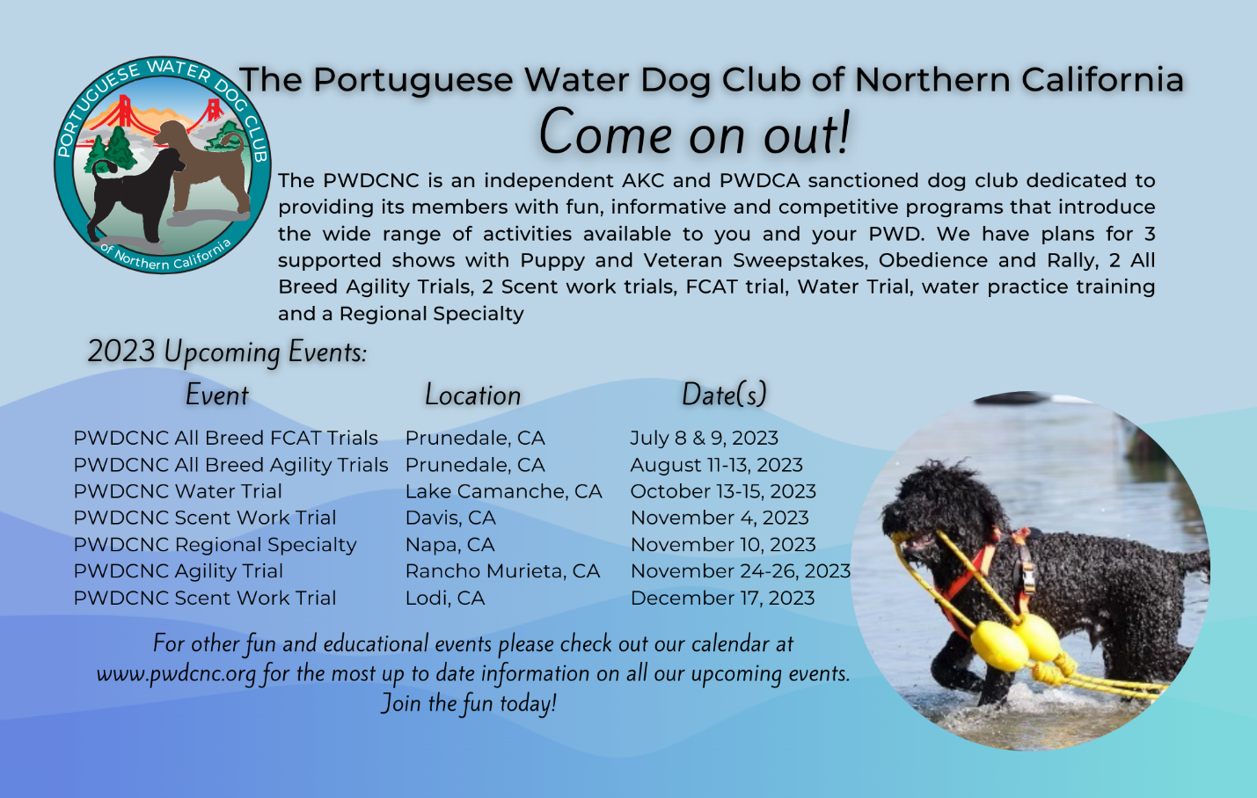
The second ad is for all the new titles earned by our members in 2022.
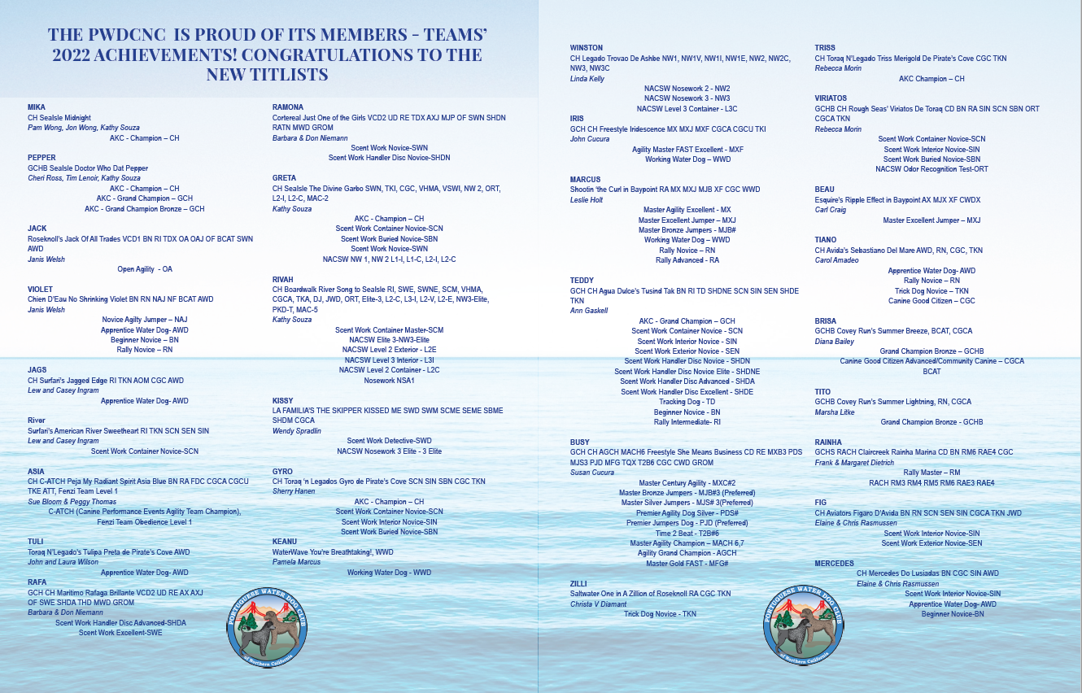
The courier team did a fantastic job on our ads/.

I would like to place a club ad in the Spring digital issue of the Courier that will go to more individuals and be viewable on the PWDCA website.
Ann has found a location for our annual meeting in Dublin and Sherry is working to get the website set up to take registration.

A vote for the 2024 regional judge will take place at the annual meeting. I will come up with a list of 5-10 judges for membership to vote on.

I am looking forward to the dry land water workshop next weekend and hope to see many of our members participating.

Obrigada

Appendix B
Recording Secretary

A General Membership meeting was held on January 29, 2023 via Zoom platform for the purpose of seeking additional nominations to the Board of Directors beyond the current 2023-2024 slate as presented by the Nominating Committee. The meeting was called to order at 7:11PM by Becky Morin.
Attendees:
Becky Morin, Ann Gaskell, Anne Paterson, Mike Paterson, Don Niemann, Lisa MacKenzie, Debbie Price, Kathy Souza, Lew Ingram, Casey Ingram and Susan Craig.

Board President Becky Morin thanked outgoing Board Member Don Niemann for his service as Corresponding Secretary and the nominating committee for their efforts.

Proposed slate for 2023-2024 term to be voted on at the Annual Meeting February 26, 2023

Officers
President, Becky Morin
Vice President, Ann Gaskell
Treasurer, Janis Welsh
Corresponding Secretary, Lisa MacKenzie
Recording Secretary, Casey Ingram

Board of Directors
Gail Browne-McDonald
Kathy Souza
Susan Craig
Dominick Amadeo

Immediate Past President
Bill Waters

Attendees were given the opportunity to put forth additional nominees, none were forthcoming. The slate will stand as is to be voted on at the Annual Meeting on February 26, 2023.

A motion to adjourn the meeting was made by Casey Ingram and seconded by Kathy Souza and unanimously approved by the members present. The meeting was adjourned at 7:17PM by Becky Morin.

Respectfully submitted,
Casey Ingram, Recording Secretary

Appendix C
Regional Specialty

Regional Specialty 2023

At the Annual Meeting we will be passing around a list of all available trophies. People can sign up and pay in cash or check. If they prefer, Janis will send them an invoice.

BISS, Obedience HC & HIT and Rally HC & HTQ will be auctioned off.

Respectfully submitted,
Becky Morin
Ann Gaskell

Appendix D
Conformation

- Woofstock Supported Entry – June 10, 2023
- Sweepstakes Judge: Mary Wells- signed a contract on file, emailed to Contra Costa Show
Committee.
- Trophies ordered and being processed
- Trophy information submitted to Contra Costa Show Committee
- AKC form submitted to hold Sweepstakes
- Trophy Budget- $400

Sweepstakes Trophies
Best in Sweepstakes Puppy – Colorful grooming apron
Best Opposite to Best of Breed Puppy- Colorful grooming apron
Best in Sweepstakes Veteran- Colorful grooming apron
Best Opposite to Best of Breed Veteran- Colorful grooming apron

Conformation -
Best of Breed – Tall Colorful Coffee Tumbler PWD design
Best of Opposite Sex – Tall Colorful Coffee Tumbler PWD design
Best of Winners – Tall Colorful Coffee Tumbler PWD design
Select Dog – Small Colorful Coffee Tumbler PWD design
Select Bitch – Small Colorful Coffee Tumbler PWD design
Winners Dog – Small Colorful Coffee Tumbler PWD design
Winners Bitch – Small Colorful Coffee Tumbler PWD design
Reserve Winners Dog – ½ apron psychedelic design
Reserve Winners Bitch - ½ apron psychedelic design
BOBOH- Not offered

- The Contra Costa Show committee sent a request to determine if the club would like to hold a meet the breed at this show. A decision needs to be made so I can submit it to the Show Committee.
  - Reply sent to gracefully decline the offer.
  - Meet the Breed will be held at the Regional in November

- Del Monte KC Supported Entry July 15, 2023
- AKC Event Application emailed to AKC to hold Sweepstakes (Veteran and Puppy) at our Supported entry.
- Sweepstakes judge needed
- Conformation/Obedience/Rally/Best Puppy
- Trophy budget- $400 looking for trophy ideas.

- Del Valle Dog Club of Livermore Supported Entry with Sweepstakes
- Sweepstakes Judge needed
- Conformation/Obedience/Rally/Agility
- Trophy Budget- $400?
2023 Regional Specialty
Judges
- Sweepstakes – Wendy Corr-Contract sent
- Conformation – Diane Collings-Contract sent
- Event is pending with AKC- event#s 2023494808, 2023494809, 2023494811

Respectfully submitted,
Becky Morin
Conformation Chair

Appendix E
Agility

Workshop
Elaine Rasmussen is checking with the place where takes agility to see if they will do a one or two day weekend workshop.

This would be foundations and introduction to agility. We want to get more agility competitors.

Ribbons
Ann is still working on. The company that made our fantastic MACH ribbon is no longer in business. The ribbons from there were about $30.00 each.

I, Ann, am finding some nice ones that are $60-$65 each.

What is my budget? I think a really nice $65.00 ribbon would be a huge draw.

I think the price would be more than covered by entry fees.

Upcoming Agility trials
Our first trial is August 11-13. We need club members to attend so we have five members present.

AKC

I, Ann, have been told AKC has changed this to three members. I will check with AKC. I am told this pertains to all AKC trials.

Respectfully submitted,
Becky Morin
Ann Gaskell

Appendix F
Water Work

Water Committee Report
Reporting Committee: Water | Report Date: February 13, 2023
Committee Chair: Kathy Souza | Reporting Period: Winter 2023
Current Activities:
WORKSHOP

We were offered, on rather short notice, the opportunity to have Karen Pratt visiting this month and offering to instruct a dry-land water workshop. Elaine was able to secure the San Leandro DTC training facility for a 1 ½ day period February 18-19. Response from club members has been wonderful. We are expecting 13 working teams and 7 auditors, including at least 4 teams brand-new to water work.

WATER TRIAL

Planning and negotiations with Lake Camanche for the 2023 trials are underway. We were informed that our original date had no cottage rentals available but by moving back to October 6-8 we can have access to all but one of the North Shore cottages. SoCal is planning their trial September 16-17 so this will give teams from each area time enough between trials to potentially attend both which always boosts attendance for each club. Judge Suzanne Malick has confirmed that she will be available for the revised dates.

WATER PRACTICE
We are moving forward with planning for practice to again be offered on Wednesdays at Lake Camanche.
Elaine has been in touch with Shadow Cliffs. The water levels are still so low in the lake that they are still not allowing fishing or swimming. At last report a couple of weeks ago, all the docks, both boat and fishing, were still on dry land. We will stay in contact with park staff going forward and, if it becomes possible, we will work with them to arrange practices there but that is strictly contingent on the lake water rising a lot more than with the recent rains.

Appendix G
Programs

Annual Meeting
Programs Annual Meeting Committee members have been working on the annual meeting. It was decided that an in-person meeting was important for the club. A zoom meeting was ruled out.

It was decided that a casual atmosphere would draw more members.

The site chosen for our annual meeting is the World of Beer in Dublin. The meeting has been changed from evening to 11:30 AM to 3:00 PM.

Lunch will start at noon. The meeting will start at 1:00.

There is both inside and outside dining.

Attendees will all gather inside after lunch for the meeting.

Fit Dog

The PWDCNC is officially an AKC Fit Dog Club. I am waiting for the banner and materials from AKC.

This means that members can get recognition for just walking their dogs and recording it on the forms supplied by AKC.

I will submit details when I get the materials from AKC.

The calendar is attached.

Respectfully submitted,
Ann Gaskell

PWDCNC 2023 & 2024 Calendar

Check our club website at pwdcnc.org for details

2023

January
January 29, 2023: PWDCNC General Membership Meeting. 7:00 PM. Zoom meeting. Details will be sent to the entire membership. Contact Ann Gaskell at Ann.Gaskell@gmail.com

February
February 18 &m19, 2023: Dry Land Water Workshop With PWDCA Water Trial Judge Karen Pratt. Three separate modules, encompassing skills for Junior through Courier. San Lorenzo Dog Training Club, 534 C Lewelling Blvd., San Leandro, CA 94579. Contact Kathy Souza at pwdlover@pacbell.net.
February 26, 2023: PWDCNC Annual Meeting.11:30 AM to 3:00 PM. World of Beer, Bar & Kitchen, 4929 Dublin Blvd., Unit 260, Dublin, CA 94568. INSIDE & OUTSIDE DINING. Contact Ann Gaskell at Ann.Gaskell@gmail.com

March

April
TENTATIVE/Date to be decided: Fun walk. Contact Ann Gaskell at Ann.Gaskell@gmail.com

May

June
Date to be decided: Annual Picnic. Contact Ann Gaskell at Ann.Gaskell@gmail.com
Date to be decided: Practice starts, Camanche Lake, Primitive Campsite. Contact Kathy Souza at pwdlover@pacbell.com
June 8-11, 2023: Saturday, June 10,2023 – _PWDCNC Supported Entry for Conformation, Contra Costa Kennel Club “WoofStock” Dog Show at the Solano County Fairgrounds, Vallejo, CA. Contact Becky Morin at Detoraq@hotmail.com

July
July 8 & 9, 2023: PWDCNC All Breed FCAT Trials, Manzanita Sports Complex, 17100 Castroville Blvd., Prunedale, CA 93907. Enter at Abbadogs.com Contact Janis Welsh at janis@ahpmllc.com and Ann Gaskell at Ann.Gaskell@gmail.com
July 14-16, 2023: Del Monte Kennel Club Dog Show, 4380 Carmel Valley Rd, Carmel-By-The-Sea, CA 93923: Supported Entry for Conformation, Obedience and Rally, on Saturday, July 15, 2023. Contact Ann Gaskell at Ann.Gaskell@gmail.com or Becky Morin at Detoraq@hotmail.com

August
August 11-13, 2023: PWDCNC All breed agility trials, Manzanita Park. Agility Trial, all breed Agility trial hosted by PWDCNC; Manzanita Park, 17100 Castroville Blvd., Prunedale, CA 93907: Enter at Abbadogs.com Contact Ann Gaskell at Ann.Gaskell@gmail.com or Becky Morin at Detoraq@hotmail.com
August 25-September 1,2023: 2023 PWDCA 30th National Specialty < https://pwdcans.org/ >, Li
Linn County Expo Center, Albany, Oregon
Linn County Expo Center, Albany, Oregon.

September

October
TENTATIVE: September 29 – _October 1 (DAY 3), 2023: PWDCNC Water Trial. Lake Camanche, North Shore, Ione, San Joaquin County, CA. The website is golakecamanche.com Contact Kathy Souza at pwdlover@pacbell.com
October 19-22, 2023: Harvest Moon Classic; Del Valle Kennel Club Dog Show, Sonoma County Event Center & Fairground, 1350 Bennett Valley Road, Santa Rosa, CA 95404. Saturday, October 21, 2023, supported Entry for Conformation, Obedience, Rally and Agility. Contact Becky Morin at Detoraq@hotmail.com
October 28: Dogtoberfest (Oktoberfest the PWD Way), Annual PWDCNC Oktoberfest and general membership meeting, lots of fun, great food, games and more: 11:30 AM to 3:30 PM Ed Levin Park,Milpitas, CA: Sandy Wool Site. Contact Ann Gaskell at Ann.Gaskell@gmail.com

November
TENTATIVE: November 4, 2023: AKC Scent Work trial, hosted by PWDCNC; PWDS have priority entry for entries received no later than 10/11/2023. Contact Kathy Souza at pwdlover@pacbell.net.
November 10,2023: PWDCNC Regional Specialty, Napa Valley Exposition, Third St and Silverado Trail, Napa, CA; Contact Ann Gaskell at Ann.Gaskell@gmail.com or Becky Morin at Detoraq@hotmail.com
November 24-26, 2023: Three day Agility Trial hosted by PWDCNC; all breed Agility Trial; Rancho Murieta, CA; Enter at Abbadogs.com Contact Ann Gaskell at Ann.Gaskell@gmail.com or Becky Morin at Detoraq@hotmail.com

December
December 17, 2023: AKC Scent Work trial, hosted by PWDCNC; Located at Dream Big Training Facility, 19681 Brandt Road, Lodi, CA, 95240; Opening Date: Wednesday - September 27, 2023 Opening Time: 12:00:00 PM. Contact Ann Gaskell at Ann.Gaskell@gmail.com

2024

January
January 28, 2024: PWDCNC General Membership Meeting. 7:00 PM. Zoom meeting. Details will be sent to the entire membership. Contact Ann Gaskell at Ann.Gaskell@gmail.com

February
February 25, 2024: PWDCNC Annual Meeting. 7:00-8:00 PM. Zoom meeting. Details will be sent to the entire membership. Contact Ann Gaskell at Ann.Gaskell@gmail.com
Dates to be decided, tentative events, 2023:
Fit Dog
Trick Dog Workshop
Rally Workshop: Introduction to Rally with Billy and Dee Dee Anderson (Basic obedience foundation required: sit, stay, finish left and right, down, stand, come)
AKC Scent Work Workshop
Fun Walks
To be Rescheduled: Marge Rogers Workshop. Two different workshops for all levels of PWD owners from first time new puppy owner to experienced competitor. Instructor: Marge Rogers, CBCC-KA, CPDT-KA. Contact Sherry Hanen at sherrypwd@gmail.com
2-7--2023-v1

