PWDCNC BOARD MEETING AGENDA & MINUTES
Date April 10, 2023 | Time: 7:30PM | Location: Zoom Meeting
Next Meeting | May 8, 2023
Subject | PWDCNC Board Meeting
Board Meetings are held on the second Monday of the month

Meeting Agenda and Minutes
This meeting was called to order by Becky Morin at 7:31 pm.
Quorum:
In Attendance
Becky Morin | Ann Gaskell | Janis Welsh
Casey Ingram  Kathy Souza  Bill Waters AB | Lisa MacKenzie  Dominick Amadeo  Susan Craig | Gail Brown-McDonald AB  Debbie Price – guest  Sherry Hanen - guest

- Minutes of the last meeting: A motion was made to accept the March 13, 2023 minutes by Kathy Souza and seconded by Ann Gaskell. The Board members unanimously concurred, and the minutes were, approved.

Board Member Reports
- Report of the President – Becky Morin – no report
COMMENTS: Becky again emphasized the need to recruit volunteers, especially for club sponsored events. She suggested that unless a particular discipline had a chair (ie: Agility, Regional Specialty, etc..) that the event should not be held. Becky stated that it is not appropriate for the same people be placed into interim chair positions again and again, even if they were willing. Lengthy discussion ensued on how best to fill in for upcoming events.
- Report of the Vice-President – Ann Gaskell - no report
- Report of the Recording Secretary – Casey Ingram - no report
- Report of the Treasurer-Janis Welsh - Appendix A
COMMENTS: $300 was approved for National Specialty Trophy with and additional $200 approved for the raffle basket.
- Report of the Corresponding Secretary – Lisa MacKenzie – Appendix B

Committee Reports
- Breeder Referral List – Linda Kelly – no report
- Rescue – Julie Conger – no report
- Health and Education – Julie Conger – no report
- Membership – Debbie Price – verbal in person
COMMENTS: Debbie will send a listing of all members who have yet to renew to Sherry for a reminder email blast. Blast will only go out to those non renewed. Roster cover photos finalized. Kathy Souza asked that a full list of members be sent to her.
- Policy and Procedure – Carole Corbett – no report
- Wavies and Curlies – Frank and Margaret Dietrich – Appendix C
- Regional Specialty – Becky Morin and Ann Gaskell – Appendix D
COMMENTS: Trophies are approved. Becky, Ann, and Janis working on the premium list. Per Janis, Abbie Garner may be willing to do hospitality again. For the 2024 RS, an email ballot blast needs to go out to choose the judges.
- Conformation – Becky Morin - Appendix E

COMMENTS:
- Agility – Becky Morin and Ann Gaskell – no report

COMMENTS: Lengthy discussion about need for more volunteers and a chair. Debbie Price voiced some interest in the chair position and will reach out to Kathy Weinberg for more details. Casey Ingram volunteered to assist Debbie with the November trial at Rancho Murietta. Volunteers are still needed for Prunedale trail in August.
- Obedience and Rally – Ann Gaskell and Anne Paterson -no report
- Junior Showmanship – Ally Lantis – no report
- FCAT – Janis Welsh – no report
COMMENTS: Still need volunteers for the July 8 and 9 trials in Prunedale.
- Water Work – Kathy Souza – Appendix F
- Scent Work – Kathy Souza – no report
- Programs and Calendar – Ann Gaskell Appendix G
COMMENTS: Janis and Ann are looking into a picnic site near Vacaville. Pena Adobe Lagoon Valley Regional Park. We may be able to include limited Scent Work and Agility intro at the picnic.

Agenda Items

Bill Waters is continuing to look at alternate IT vendors for the Website

Old Business/Tasks

New Business

Adjournment – A motion to adjourn the meeting was made by Ann Gaskell and seconded by Janis Welsh. The motion was approved unanimously by the board and the meeting was adjourned at 9:25 PM.

Appendix A
Treasurer

Committee Report
Reporting Committee: Treasurer | Report Date:11/14/2022
Committee Chair: Janis Welsh | Reporting Period:

Current Activities:

Membership

So far we have $2130.00 in membership dues in. Slightly behind last years income at this time. A renewed reminder for members should go out.

Dryland workshop summary
Income $1450.00
Expenses $836.07
Total: $613.93

Insurance
To be in compliance with the PWDCA we have had to extend our insurance coverage to January 1, 2024 instead of the September renewal dates. This is a good thing as we have several events late in the year and when certificates of insurance were required early it lead to issues.
I have provided Insurance Certificate to the PWDCA as requested and Lisa Mackenzie completed the sanctioning requirements. We are sanctioned for 2023.

I provided 2 certificates of Additionally Insured for the August Agility Trial in Prunedale ($159.00) that are required (County of Monterey, Parks & Rec Department) .

Budget Discussion
- I made conservative estimate that our income for 2023/2024 will be $24500.00
- Expenses to discuss
  - National Specialty raffle basket donation
  - National Specialty Trophy donation
- Website development or changes? Our expenses with J Samorano were very low last year at only $4430.00. However, there are still some major issues.
The water committee has abandoned the website and utilized other platforms to run the water program.

- Water Program
Included is an estimated water program budget supplied by Kathy Souza. Thank you Kathy.

- Picnic and Dogtoberfest
To facilitate budget investigation, I utilized Vacaville’s, Peno Adobe Lagoon park as a site for a spring picnic. I have not received conformation of available dates for the group picnic site I sent inquiry for June 24 or 25.

Picnics and October fest would be burgers/hotdogs and other pot luck food.

- Regional and Water Program were estimated to have a $1000 over run but could just as easily could be in the black. It is hard to tell as these are participation driven and weather can have a big impact.

- Added a Seminars and Workshop item of $500.00 in the event a activity arises.

Respectfully Submitted,

Janis Welsh

PWDCNC Estimated Budget 2023-2024
Income estimated 2023-2024
* included only (fairly) certain income
Membership Dues | 6000
Agility 2 trials | 12000
FCAT | 1500
Scentwork trials 2 trials | 5000
24500

Courier
New title ad 560
Each issue x 2 150 1/2 page ad 300
Natioanal Speciality 1/2 page ad 65
925
Gifts and Donations
National Specialty Trophy 300
need to discuss
Raffle basket 200
have rally cards, and cones
PWD Health Foundation Membership & deaths 1200

Administration
Google 576
Mailchimp 240
Quicken Accounting 59
Website
Entropic 281
Gravity forms 149
Site management Jeffrey Samorano 4000
4430
Trailor Storage Blum road 60/month 720
Storage unit Public 85/month 1020
Directory 500
Postage/Corresponding Secretary 350
Insurance
liability policy 640
B of D Policy 540
Agility special policy 156
1336
Supported Entry
Woofstock 420
Carmel 420
Del Valle 420
1260
Spring Picnic 1000
Dogtoberfest 1000
Annual meeting 500
Regional 1000
Water Program 1000
Seminairs and workshops 500
18116
INCOME
Water Prog Inc
Water Pract Inc 743.00
Water Seminar 1,425.00
Water Trial
Donations 100.00
Ducks 254.00
Entries 3,031.00
Meals 1,520.00
Practice slot 95.00
raffle H2O trial 160.00
Water Trial Camping 1,800.00
TOTAL Water Trial 6,960.00
TOTAL Water Prog Inc 9,128.00

EXPENSES
Water Expenses
Trailer Storage 720.00
Water Equipment 72.00
Water Pract Exp 928.00
Water Sem Exp 825.00
Water Trial
Camping & Cabin rental 2,800.00
Ducks 200.00
Judges 800.00
Meals 950.00
Participation goody bags 200.00
Ribbons 250.00
Site Rental 525.00
Water Trial Administrative 500.00
TOTAL Water Trial 6,225.00
TOTAL Water Expenses 8,770.00

Spring picnic/ Dogoberfest estimate
Lagoon Valley Park Picnic area 265
Dog toys 5 x 40 200
Cake 60
Hot dogs /burgers 200
pot luck
paper plates/cups/garbage bags 30
Alcohol fee 77
832

Appendix B
Corresponding Secretary

Certificates mailed to members
Thank you card sent to restaurant owner of venue for the annual meeting
Thank you card sent to Karen Pratt for Dry Dock Training
Sanctioning Report completed and sent to Janis
Seven New Member Packets sent

Lisa MacKenzie
Corresponding Secretary

Appendix C
Wavies and Curlies

Here's a message you can pass on, either verbatim or paraphrased:
Several members of the Wavies & Curlies Editorial and Advisory Boards met in a Zoom meeting on March 24. The main purpose of the meeting was to finalize the contents of the upcoming newsletter, which is planned for release at the end of April. In addition, incoming Editor Cheri Ross attended the meeting and introduced herself. We look forward to giving her as much support as she needs in preparing for the next edition.
Best regards, Frank

Appendix D
Regional Specialty

☐ Must be a Regular Member to vote
☐ Please print and sign your name on the ballot below
☐ Vote for three candidates, ranking 1st, 2nd, 3rd
☐ Ballots must have three candidates ranked or they will not be counted

_____ Joan Luna Liebes
_____ Patricia Trotter
_____ Lee Whittier
_____ Eric Liebes
_____ Christine Martinez
_____ Gary Anderson
_____ Faye Strauss
_____ Paula Nykiel

Regular Voting Member Name: ____________________________________________

Member Signature: ______________________________________________________

Did you vote for THREE judges, ranking them 1, 2, and 3? ☐

Voting Results:

1st place judge will be selected for 2024 regional. If 1st place judge is not available or slated to judge the 2024 PWDCA National Specialty, then the 2nd and 3rd place judge will be asked to judge in 2024 in order.

Absentee Voting: Must be received no later than 5 pm April 28, 2023

Please email the absentee ballot to Becky Morin, Conformation Chair at detoraq@hotmail.com.

Appendix E
Conformation

Conformation Chair Report April 10, 2023

- Woofstock Supported Entry – June 10, 2023
- Sweepstakes Judge: Mary Wells- signed a contract on file, emailed to Contra Costa Show
Committee.
- Trophies received and receipt for shipping costs ($22.80) to be sent to Treasurer.
- Premium list reviewed and corrects submitted to show committee
- AKC form submitted to hold Sweepstakes
- Trophy Budget- $400 total cost for trophies within budget.

- Del Monte KC Supported Entry July 15, 2023
- AKC Event Application emailed to AKC to hold Sweepstakes (Veteran and Puppy) at our Supported entry.
- Sweepstakes judge David Smith signed contract received.
- Conformation/Obedience/Rally/Best Puppy
- Trophy budget- will repurpose prior trophies for this show

- Del Valle Dog Club of Livermore Supported Entry with Sweepstakes
- Sweepstakes Judge needed
- Conformation/Obedience/Rally/Agility
- Trophy Budget- $400
Trophy ideas-
  - pumpkins in PWD design since this is the Harvest Moon Classic
  - power coated spray bottles
  - Leash/coat hangers
  - totes
- 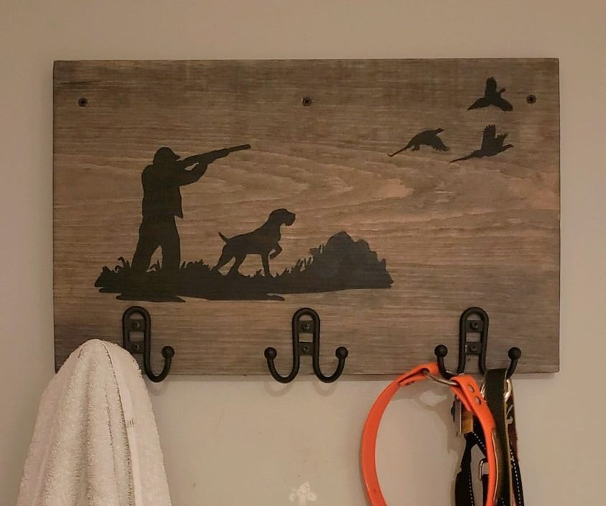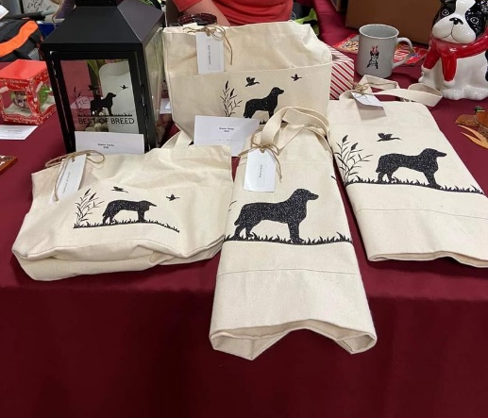

2023 Regional Specialty
Judges
- Sweepstakes – Wendy Corr-Contract sent
- Conformation – Diane Collings-Contract sent
- Events approved with AKC- event#s 2023494808, 2023494809, 2023494811
- Trophy Ideas: I have reached out to Angie Robinson for the following trophies:
  - 1st- 4th place in the classes- hand-painted sand dollar
  - Top trophies hand-painted ceramic cookie jars in various sizes
  - Non-regular class winner- glass cutting board PWD design

2024 Regional Specialty Judges Selection
I contacted Inge at Wine Country without success for 2024 Judges. I have come up with a ballot for our 2024 Specialty from prior ballots and votes from members. Please review and advise if we can send this out immediately in a blast. The return date is 4/28.

Respectfully submitted,
Becky Morin
Conformation Chair

Appendix F
Water Work

Water Committee Report
Reporting Committee: Water | Report Date: April 10, 2023
Committee Chair: Kathy Souza | Reporting Period: Spring
Recap of Activities:

DRY LAND WORKSHOP
I’ve continued to receive very positive feedback from workshop attendees.
WATER TRIALS
Elaine and I are reviewing the proposed contract and will meet with Brian of their staff to work out any issues and take a look at the lake levels.
Elaine has been in contact with staff at Shadow Cliffs and the outlook for any use there is still very poor. The docks are all still high and dry. This link will take you to a recent article that provides background information about why Shadow Cliffs isn’t getting water the way other bodies of water have this winter. https://www.pleasantonweekly.com/news/2023/01/26/guest-opinion----shadow-cliffs-a-microcosm-of-californias-water-complexities
The trial application is still waiting for the insurance certificate to submit the application.

Appendix G
Calendar

PWDCNC 2023 & 2024 Calendar
Check our club website at pwdcnc.org for details
2023
January
January 29, 2023: PWDCNC General Membership Meeting. 7:00 PM. Zoom meeting. Details will be sent to the entire membership. Contact Ann Gaskell at Ann.Gaskell@gmail.com
February
February 18 &m19, 2023: Dry Land Water Workshop With PWDCA Water Trial Judge Karen Pratt. Three separate modules, encompassing skills for Junior through Courier. San Lorenzo Dog Training Club, 534 C Lewelling Blvd., San Leandro, CA 94579. Contact Kathy Souza at pwdlover@pacbell.net.
February 26, 2023: PWDCNC Annual Meeting.11:30 AM to 3:00 PM. World of Beer, Bar & Kitchen, 4929 Dublin Blvd., Unit 260, Dublin, CA 94568. INSIDE & OUTSIDE DINING. Contact Ann Gaskell at Ann.Gaskell@gmail.com
March
April
TENTATIVE/Date to be decided: Fun walk. Contact Ann Gaskell at Ann.Gaskell@gmail.com
May
June
Date to be decided: Annual Picnic. Contact Ann Gaskell at Ann.Gaskell@gmail.com
Date to be decided: Practice starts, Camanche Lake, Primitive Campsite. Contact Kathy Souza at pwdlover@pacbell.com
June 8-11, 2023: Saturday, June 10,2023 – _PWDCNC Supported Entry for Conformation, Contra C_o_s_t_a_ _K_e_n_n_e_l_ _C_l_u_b_ _“W_o_o_f_s_t_o_c_k_” _D_o_g_ _S_h_o_w_;_ _S_o_l_a_n_o_ _C_o_u_n_t_y_ _F_a_i_r_g_r_o_u_n_d_s_,_ _V_a_l_l_e_j_o_,_ _C_A_._ _C_o_n_t_a_c_t_ _B_e_c_k_y_ _Morin at Detoraq@hotmail.com
July
July 8 & 9, 2023: PWDCNC All Breed FCAT Trials, Manzanita Sports Complex, 17100 Castroville Blvd., Prunedale, CA 93907. Enter at Abbadogs.com Contact Janis Welsh at janis@ahpmllc.com and Ann Gaskell at Ann.Gaskell@gmail.com
July 14-16, 2023: Del Monte Kennel Club Dog Show, 4380 Carmel Valley Rd, Carmel-By-The-Sea, CA 93923: Supported Entry for Conformation, Obedience and Rally, on Saturday, July 15, 2023. Contact Ann Gaskell at Ann.Gaskell@gmail.com or Becky Morin at Detoraq@hotmail.com
August
August 11-13, 2023: PWDCNC All breed agility trials, Manzanita Park. Agility Trial, all breed Agility trial hosted by PWDCNC; Manzanita Park, 17100 Castroville Blvd., Prunedale, CA 93907: Enter at Abbadogs.com Contact Ann Gaskell at Ann.Gaskell@gmail.com or Becky Morin at Detoraq@hotmail.com
August 25-September 1,2023: 2023 PWDCA 30th National Specialty < https://pwdcans.org/ >, Li
Linn County Expo Center, Albany, Oregon
Linn County Expo Center, Albany, Oregon.
September
October
October 6 – _October 8, 2023: PWDCNC Water Trial. Lake Camanche, North Shore, Ione, San Joaquin County, CA. The website is golakecamanche.com Contact Kathy Souza at pwdlover@pacbell.com
October 19-22, 2023: Harvest Moon Classic; Del Valle Kennel Club Dog Show, Sonoma County Event Center & Fairground, 1350 Bennett Valley Road, Santa Rosa, CA 95404. Saturday, October 21, 2023, supported Entry for Conformation, Obedience, Rally and Agility. Contact Becky Morin at Detoraq@hotmail.com
October 28: Dogtoberfest (Oktoberfest the PWD Way), Annual PWDCNC Oktoberfest and general membership meeting, lots of fun, great food, games and more: 11:30 AM to 3:30 PM Ed Levin Park,Milpitas, CA: Sandy Wool Site. Contact Ann Gaskell at Ann.Gaskell@gmail.com
November
TENTATIVE: November 4, 2023: AKC Scent Work trial, hosted by PWDCNC; PWDS have priority entry for entries received no later than 10/11/2023. Contact Kathy Souza at pwdlover@pacbell.net.
November 10,2023: PWDCNC Regional Specialty, Napa Valley Exposition, Third St and Silverado Trail, Napa, CA; Contact Ann Gaskell at Ann.Gaskell@gmail.com or Becky Morin at Detoraq@hotmail.com
November 24-26, 2023: Three day Agility Trial hosted by PWDCNC; all breed Agility Trial; Rancho Murieta, CA; Enter at Abbadogs.com Contact Ann Gaskell at Ann.Gaskell@gmail.com or Becky Morin at Detoraq@hotmail.com
December
December 17, 2023: AKC Scent Work trial, hosted by PWDCNC; Located at Dream Big Training Facility, 19681 Brandt Road, Lodi, CA, 95240; Opening Date: Wednesday - September 27, 2023 Opening Time: 12:00:00 PM. Contact Ann Gaskell at Ann.Gaskell@gmail.com
2024
January
January 28, 2024: PWDCNC General Membership Meeting. 7:00-8:00 PM. Zoom meeting. Details will be sent to the entire membership. Contact Ann Gaskell at Ann.Gaskell@gmail.com
February
February 25, 2024: PWDCNC Annual Meeting.. 11:30 AM to 3:00 PM. Location TBD. Details will be sent to the entire membership Contact Ann Gaskell at Ann.Gaskell@gmail.com
Dates to be decided, tentative events, 2023:
Fit Dog
Trick Dog Workshop
Rally Workshop: Introduction to Rally with Billy and Dee Dee Anderson (Basic obedience foundation required: sit, stay, finish left and right, down, stand, come)
AKC Scent Work Workshop
Fun Walks
To be Rescheduled: Marge Rogers Workshop. Two different workshops for all levels of PWD owners from first time new puppy owner to experienced competitor. Instructor: Marge Rogers, CBCC-KA, CPDT-KA. Contact Sherry Hanen at sherrypwd@gmail.com
3-11-2023 v.2

