PWDCNC BOARD MEETING AGENDA & MINUTES
Date August 14, 2023 | Time: 7:30PM | Location: Zoom Meeting
Next Meeting | September 11, 2023
Subject | PWDCNC Board Meeting
Board Meetings are held on the second Monday of the month

Meeting Agenda and Minutes
This meeting was called to order by Becky Morin at7:35 pm.
Quorum:
In Attendance
Becky Morin | Ann Gaskell | Janis Welsh
Casey Ingram | Lisa MacKenzie | Gail Brown-McDonald
Kathy Souza | Dominick Amadeo | Susan Craig
Bill Waters AB | Guest: Sherry Hanen

- Minutes of the last meeting: A motion was made to accept the minutes by and seconded by . The Board members unanimously concurred, and the minutes were, approved.

Board Member Reports
- Report of the President – Becky Morin – no report
- Report of the Vice-President – Ann Gaskell - no report
- Report of the Recording Secretary – Casey Ingram - no report
- Report of the Treasurer-Janis Welsh – Appendix A
- Report of the Corresponding Secretary – Lisa MacKenzie – no report

Committee Reports
- Breeder Referral List – Linda Kelly – no report
- Rescue – Julie Conger - Appendix B
- Health and Education – Julie Conger – no report
- Membership – Debbie Price/Janis Welsh – no report
- Policy and Procedure – Carole Corbett – no report
- Wavies and Curlies –Cheri Ross – no report
- Regional Specialty – Becky Morin and Ann Gaskell - Appendix C
COMMENT:
Website trophy donation is up but needs refining. Once done, an email blast will go to membership
- Conformation – Becky Morin – no report
- Agility – Becky Morin, Ann Gaskell, and Leslie Holt – no report
- Obedience and Rally – Ann Gaskell and Anne Paterson – no report
- Junior Showmanship – Ally Lantis – no report
- FCAT – Janis Welsh – Appendix D
- Water Work – Kathy Souza – Appendix E
- Scent Work – Kathy Souza – Appendix F
COMMENT: Proposed November trial likely to be rescheduled due to a lack of venue and conflict with major trial already scheduled in Monterey.
- Programs and Calendar – Ann Gaskell - Appendix G

Agenda Items
Wavies and Curlies
See Appendix H for proposal
COMMENTS: Gift for Frank and Margaret is still in process. Ann to follow up. Becky and Cheri Ross have a proposed an issue schedule as well as a change to the structure of the review process and individuals involved. Becky to send write up to board for further review. Preliminary editorial board proposed was Cheri Ross as editor (Frank as Editor Emeritus), Casey Ingram, Becky Morin, Kathy Souza, Sherry Hanen, and Elaine Rasmussen. It is proposed the secondary editorial group be disbanded as it does not appear to be necessary.

Old Business/Tasks

New Business

Adjournment – A motion to adjourn the meeting was made by Casey Ingram and seconded by Susan Craig. The motion was approved unanimously by the board and the meeting was adjourned at 9:05P.

Appendix A
Treasurer Report

Committee Report
Reporting Committee: Treasurer | Report Date:August 6, 2023
Committee Chair:Janis Welsh | Reporting Period:

Current Activities:
Gail Browne-McDonald submitted the taxes. Thank you Gail!

Attached is the Banking Summary March 1 – August 6 and account balances

Account | 8/6/2023  Balance
Bank Accounts
BUSINESS MARKET RATE SAVINGS | 52,662.47
Stripe | 245.67
WFB Checking | 4,556.02
TOTAL Bank Accounts | 57,464.16
Visa 5532 | -501.36
OVERALL TOTAL | 56,962.80
Other Observations:
- Water Practice payments are starting to come in.
- I will need to know what ribbons are used in 2023 water trial to move them out of prepaid expenses.
- Paid PWDCA Foundation for membership donation and Rainbow Bridge donations

March 1, 2023 – August 6, 2023

INFLOWS:

CATEGORY
Membership Dues 4,650.00

Programs Income
Annual Meetings 20.00
Raffle 20.00
TOTAL Annual Meetings 40.00

TOTAL FCAT Income 2,375.00

Reg Spec Inc
Trophy Donations 300.00
TOTAL Reg Spec Inc 300.00

Water Program Income
Water Practice Income 414.00
Water Trial
Donations 5.00
Meals 70.00
Practice slot 10.00
TOTAL Water Trial 85.00
Water Workshop Seminar 155.00
TOTAL Water Program Income 654.00

TOTAL Programs Income 3,369.00

Visa Cash Back 47.29

TOTAL INFLOWS 8,066.29

OUTFLOWS:

CATEGORY

Admin
Courier Advertising 300.00
Insurance 348.74
Office Expense 146.98
Storage 540.00
Trailer Acces 269.35
TOTAL Admin 1,605.07

Business Expenses 388.00
Fees & Charges 112.10

Gifts & Donations
Gift 150.00
TOTAL Gifts & Donations 150.00

Programs Exp 78.00
Agility - Exp 300.00
Annual Meeting exp 737.03
Picnic Expense 119.00
PWDCA Nat Spec 300.00

Reg Spec Exp
Awards
Ribbons 844.75
Trophies 574.00
TOTAL Reg Spec Exp 1,418.75

Scentwork Prog Exp
Scentwork Trial AKC Fee 35.00
TOTAL Scentwork Prog Exp 35.00

CASH FLOW March 1/2023 - August 6/2023

CATEGORY
Supported Entry
Carmel 10.00
Harvest Moon Classic 352.13
TOTAL Supported Entry 362.13

Water Expenses
Trailer Storage 300.00
Water Equipment 185.20
Water Sem Exp 19.50
Water Trial 446.38
Ducks 181.86
Site Rental 300.00
Water Trial Administrative 50.00
TOTAL Water Trial 978.24
Water Workshop 646.07
TOTAL Water Expenses 2,129.01

Website 1,368.00

TOTAL Programs Exp 6,846.92
TOTAL OUTFLOWS 9,102.09
OVERALL TOTAL -1,035.80

Appendix B
Rescue

Rescue Report: Very busy in the last few months with some older (10-plus years) PWD’s needing new homes. Would appreciate your contacting me with names of folks who are willing to take in an elderly Rescue Portie.
Julie Conger
19021 Kenleigh Drive
Sonoma, CA 95476-6014
julieconger55@gmail.com

Appendix C
Regional Specialty

Committee Report
Reporting Committee: Regional Specialty | Report Date:August 6, 2023
Committee Chair:Becky Morin/Ann Gaskell | Reporting Period:

Current Activities:
Paid Angie Robinson for Trophies $574.00
Requested Host Club(Wine County) permission form for AKC records. I requested it as indefinite period so we don’t have to do it every year. While speaking with Inge she said she had forgotten to send a bill for judges expenses from last year (Bill Murray) I said please send it, but as of yet she has not.

All AKC letters of approval have been received.

I have submitted the premium to MB-F but have not got the draft back for our review yet.

I am working with Sherry to update the website for this years Regional Specialty.
The Trophy donation page is up on the Shop but a little more refining needs to be done, but it is functioning.

Appendix D
FCAT

FCAT Weekend
On July 8 – 9 the PWDCNC hosted our 3rd FCAT rial in Manzanita Park in Prundedale CA. IT was a perfect cool weekend with our highest turn out yet. Over 2 days we had 329 runs generating $2375.00 income for our club.
It is thanks to the volunteers who step up and take the time to work at these events that so our club can provide programs and exceptional trophies at supported entry shows. It would be great to see some conformation club members come out and volunteer even if your dogs are not running. It is a lot of fun!
A special thank you to,
Jim and Leslie Holk, Susan and Carl Craig, Janis and Chris Welsh, Sherry Hanen, Ann Gaskell, Judy Knorr , Ealine Rasmussen and Vanessa MacDonald (a doodle owner) who help to make this event a success.
The event had regular runs for the experienced dogs and a learn and run for dogs that were new to the sport. Here are a few photos of the day and the happy flying PWD’s.
In all we had 8 PWD’s who ran
Briza, Bella, and Michelle tried it for the first time They quickly learned the game and were running like cheetahs in minutes. Teddy, Gyro, Soda, Violet and Jack added to their points toward FCAT titles.

Susan Craig as flagger

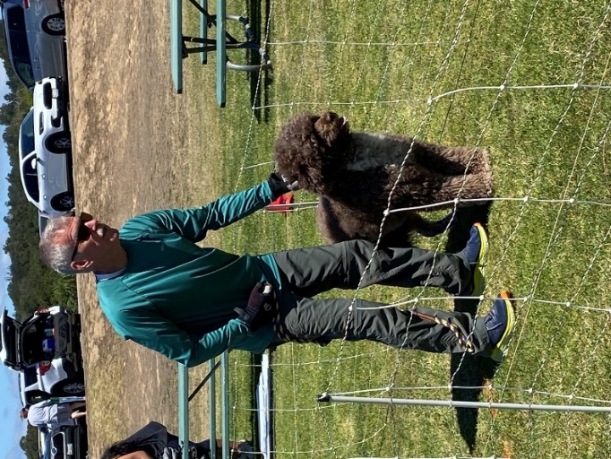

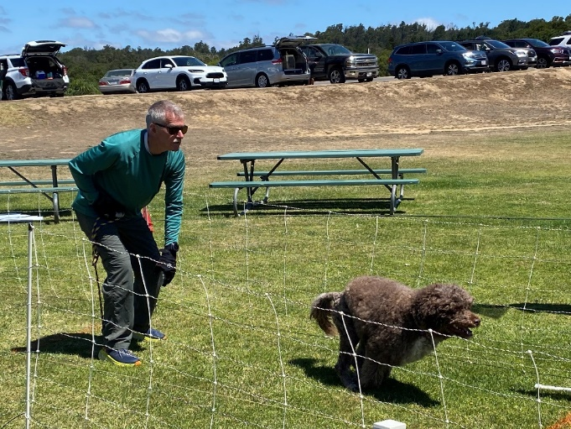

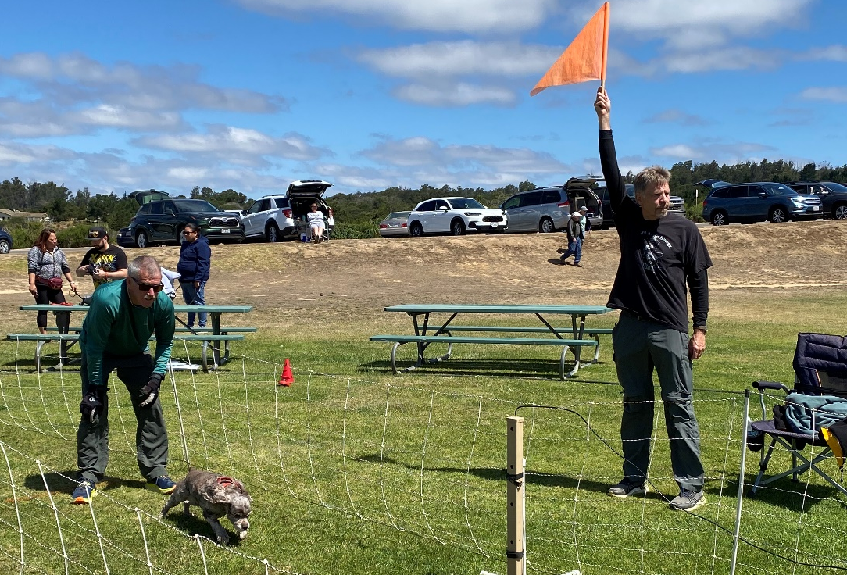
Carl Craig Starter flagger and Jim Holt dog releaser

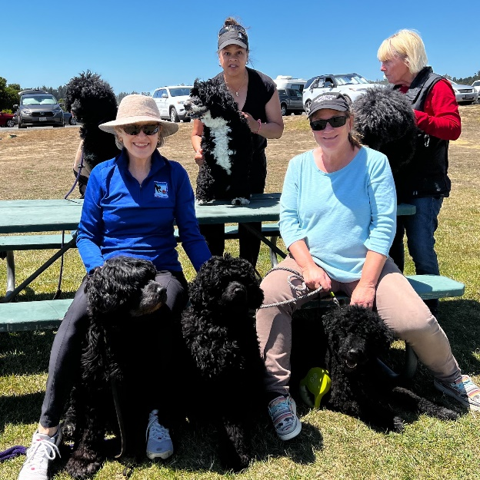
Judy Knorr, and Apollo and Michelle, Janis Welsh and Jack,
Elaine Rasmussen and Briza ,Linda Schmith and Bella, Ann Gaskell and Teddy
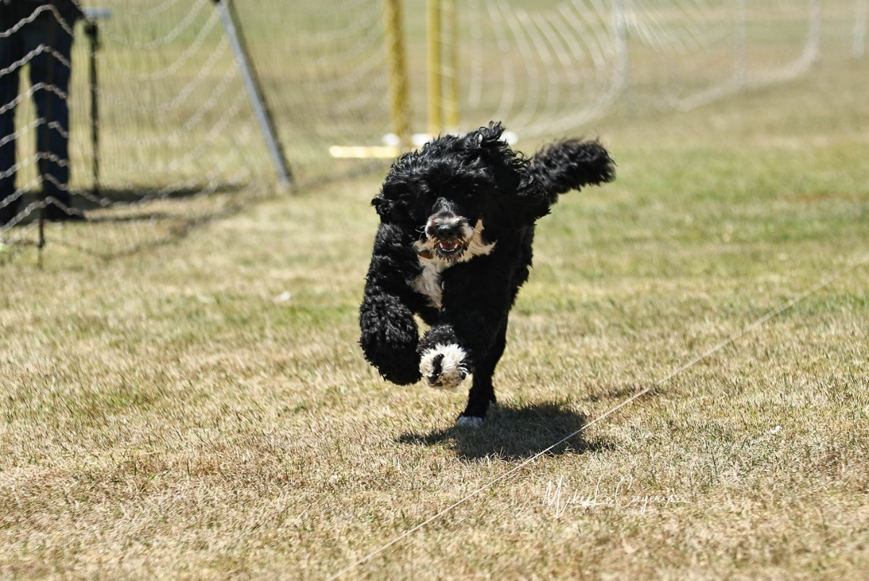
First Time Bella Learns Quickly

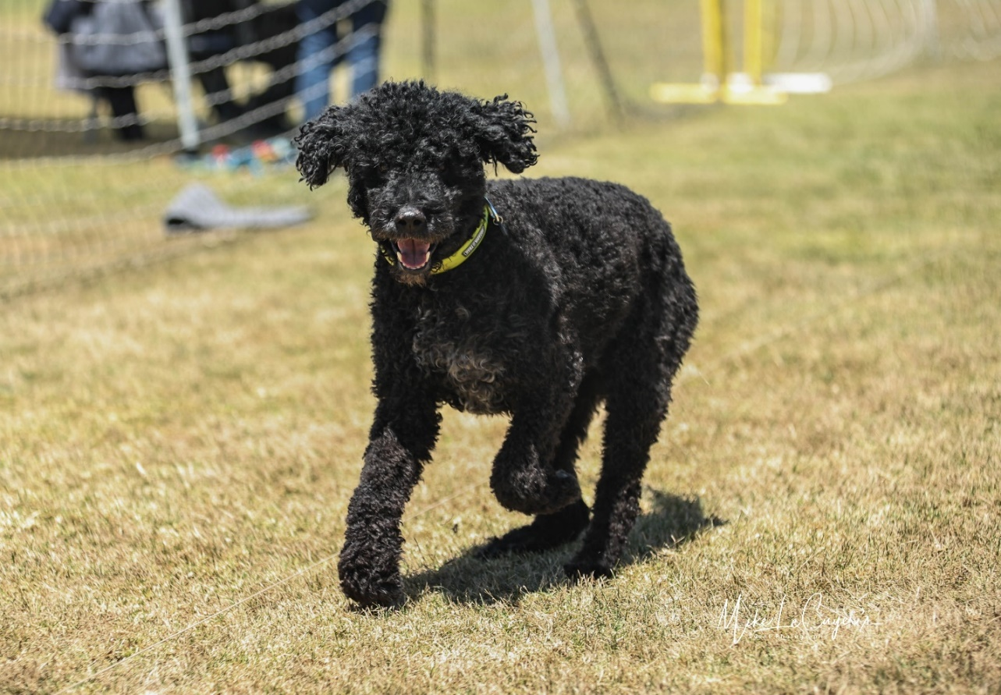
Loping Jack smiles for the photographer

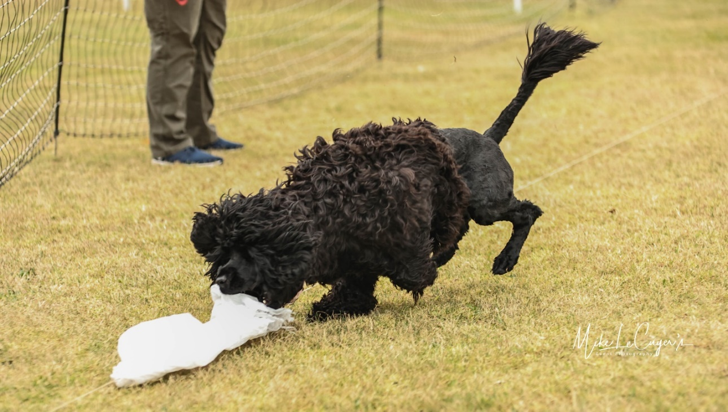
Victory!! Violet catches the Bag!

Appendix E
Water Work

Reporting Committee: Water | Report Date: August 12, 2023
Committee Chair: Kathy Souza | Reporting Period: Summer
Recap of Activities:

WATER PRACTICE
Attendance has remained high for the weekly practices. The mornings remain as the more popular slots. If anyone is asking about availability please direct them to the Supersaas signup. https://www.supersaas.com/schedule/PWDCNC/PWDCNC_Water_Practice?view=week&day=28&month=6 There are still plenty of spaces open for teams interested in practicing where we will be trialing in October.
The varying levels of the lake continues to require us to move the practice site each week but it has not been a serious problem. The other issue has been the fairly heavy number of campers using the Primitive camping area. Apparently the higher water levels have brought out more campers than were seen during the drought years.
We still do not have a firm date as to when we will have boats moored at Shadow Cliff. Carl has taken my boat to his home and on those days he goes to the Shadow Cliff practices take it out for members use. If the boat is not available, Elaine provides 2 Mo-Marsh stands and assists with the various ways to use those. Signups for Shadow Cliff are also available at the SuperSaas link in paragraph 1.
The premium list for the October trials has been posted on Perfdog and an email blast went out to the membership announcing that information.

Appendix F
Scent Work

Scent Work Committee Report
Reporting Committee: Scent Work | Report Date: August 14, 2023
Committee Chair: Kathy Souza | Reporting Period: Summer 2023
Current Activities:

All paperwork has been completed for the December trial and information is available on AKC.

The proposed November trial is still pending. This is the same weekend as the very popular Monterey SW trials who are using most of the more experienced NorCal judges. I still have not gotten a commitment on a site for the trial and without that securing judges is premature not knowing how many classes we can offer. It may well be that we should look for a date without the heavy competition from another club in the NorCal region.

Appendix G
Programs and Calendar

My report for Programs:

Fit Dog
I am adding Group Fit Dog Walks to our 2024 calendar. The first one is January 20, 2024. I do not have a location as yet.

I would like to order 50 free Fit Dog magnets. I would hand them out to all walkers who say they have not received one. Here is the link: https://docs.google.com/forms/d/e/1FAIpQLSczt5hqIH1QjPcvpnwLhyexF8GNG8Cf9QABwQ8EE_Oa0bqNdg/viewform

Respectively submitted,
Ann Gaskell

PWDCNC 2023 & 2024 Calendar
Check our club website at pwdcnc.org for details

2023

August
August 11-13, 2023: PWDCNC All breed agility trials, Manzanita Park. Agility Trial, all breed Agility trial hosted by PWDCNC; Manzanita Park, 17100 Castroville Blvd., Prunedale, CA 93907: Enter at Abbadogs.com Contact Ann Gaskell at Ann.Gaskell@gmail.com or Becky Morin at Detoraq@hotmail.com
August 25-September 1,2023: 2023 PWDCA 30th National Specialty < https://pwdcans.org/ >, Li
Linn County Expo Center, Albany, Oregon
Linn County Expo Center, Albany, Oregon.

September

October
October 6 – October 8, 2023: PWDCNC Water Trial. Lake Camanche, North Shore, Ione, San Joaquin County, CA. The website is golakecamanche.com Contact Kathy Souza at pwdlover@pacbell.com
October 19-22, 2023: Harvest Moon Classic; Del Valle Kennel Club Dog Show, Sonoma County Event Center & Fairground, 1350 Bennett Valley Road, Santa Rosa, CA 95404. Saturday, October 21, 2023, supported Entry for Conformation, Obedience, Rally. Contact Becky Morin at Detoraq@hotmail.com

November
TENTATIVE: November 4, 2023: AKC Scent Work trial, hosted by PWDCNC; PWDS have priority entry for entries received no later than 10/11/2023. Contact Kathy Souza at pwdlover@pacbell.net.
November 10,2023: PWDCNC Regional Specialty, Napa Valley Exposition, Third St and Silverado Trail, Napa, CA; Contact Ann Gaskell at Ann.Gaskell@gmail.com or Becky Morin at Detoraq@hotmail.com
November 24-26, 2023: Three day Agility Trial hosted by PWDCNC; all breed Agility Trial; Rancho Murieta, CA; Enter at Abbadogs.com Contact Ann Gaskell at Ann.Gaskell@gmail.com or Becky Morin at Detoraq@hotmail.com

December
December 17, 2023: AKC Scent Work trial, hosted by PWDCNC; Located at Dream Big Training Facility, 19681 Brandt Road, Lodi, CA, 95240; Opening Date: Wednesday - September 27, 2023 Opening Time: 12:00:00 PM. Contact Ann Gaskell at Ann.Gaskell@gmail.com

2024

January
January 20, 2024: Group Fit Dog Walk: Location to be decided. Contact Ann Gaskell at Ann.Gaskell@gmail.com
January 28, 2024: PWDCNC General Membership Meeting. 7:00-8:00 PM. Zoom meeting. Details will be sent to the entire membership. Contact Ann Gaskell at Ann.Gaskell@gmail.com

February
February 25, 2024: PWDCNC Annual Meeting.. 11:30 AM to 3:00 PM. Location TBD. Details will be sent to the entire membership Contact Ann Gaskell at Ann.Gaskell@gmail.com

Dates to be decided, tentative events, 2024:
Fit Dog – Ongoing. Contact Ann Gaskell at ann.Gaskell@gmail.com
Trick Dog Workshop
Rally Workshop: Rally with Billy and Dee Dee Anderson (Basic obedience foundation required: sit, stay, finish left and right, down, stand, come). Contact Ann.Gaskell@gmail.com
AKC Scent Work Workshop
To be Rescheduled: Marge Rogers Workshop. Two different workshops for all levels of PWD owners from first time new puppy owner to experienced competitor. Instructor: Marge Rogers, CBCC-KA, CPDT-KA. Contact Sherry Hanen at sherrypwd@gmail.com

8-12-23-2023 v. 1

Appendix H

Wavies and Curlies Newsletter Proposal
EDITORIAL BOARD:
- Cheri Ross (Editor),
- Casey Ingram,
- Sherry Hanen
- Rebecca Morin,
- Elaine Rasmussen (pending a check)
- Kathy Souza

ADVISORY BOARD: disband as we now have a professional editor, and the advisory committee is no longer needed to review or proofread
- Elinor Cullen,
- Ann Gaskell,
- Sherry Hanen,
- Paula Li,
- Elaine Rasmussen,
- Kathy Souza

Cheri recommends 1 Board (no more than 5 people and Frank will remain Editor Emeritus but not included on the Board)
In my view the Editorial Board should
1) oversee the overall plan for content and regular publication of the newsletter,
2) review the draft in progress and
3) approve the final version before release.
4) be ready to be consulted as needed during development of contents in individual issues.

Annual Plan for Newsletter
As far as the overall annual plan for the newsletter going forward:
- See excel screen shot that shows three issues per year, issue date of each issue, events during time period and type of content suggested.
- Room to develop further content based on yearly activities of the club and the target publication dates.
  - Add more articles on articles on training different activities,
  - dog life-stage development (maybe in the Dear Abby format),
  - other content particularly targeted at pet people
- Cheri would like to survey the membership about the newsletter and communication in general to see what addresses their needs and appeals to their interests.
  - If the feedback indicates the newsletter is too seldom or frequent we can change up the publication plan

Annual Newsletter Tentative plan
MONTH | EVENT | TYPE OF CONTENT | ISSUE DATE | NOTES
December |  |  |  | In this issue we have space to develop new content
 | PWDCNC-hosted Scent Work Trial | article, photos, results
January
February
 | Water training workshop | article on training water work
 | PWDCNC Annual mtg | report
March
 |  |  | 31-Mar
April | Fun Walk | short description, photos
 | Annual Picnic | article, photos
May
 | Weekly Water Practice begins
June | Supported entry, Contra Costa (Woofstock) | article, photos, results in conformation
 | Tentative PWDCNC-hosted Scent Work Trial | article, photos, results
July
 | PWDCNC FCAT Trials | article, photos
 | Supported entry, Del Monte | results in conformation, rally, obedience | 31-Jul
August
 | PWDCNC-hosted All Breed Agility Trials | article, photos
 | PWDCA National Specialty | article, photos, results in all events
September
October | PWDCNC Water Trial | article, photos/videos, results
 | Supported entry, Del Valle | article, photos, results in conformation, obedience, rally, agility
November | Tentative: PWDCNC-hosted Scent Work Trial | article, photos, results
 | PWDCNC-hosted All Breed Agility Trial | article, photos, results
 | PWDCNC Regional Specialty | article, photos, results | 30-Nov

